Apartment Complex
Address for sat nav - Isla Plana Village, Apartment 8P, Calle de Isla de Buda, 30868 Isla Plana, Cartagena, Spain.
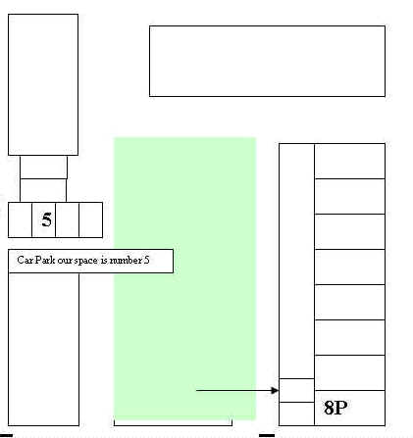

Calle de Isla De Buda
Block 1
Calle Isla Hierto
North
To the Sea 150 Metres
Calle Isla Norte
E-22 Ctra de la Isla Plana
8P
5
Comunal Garden
The middle one of the 3 gates leads up the stairs to our apartment.
Towards Cartagena
Towards Peurto Mazarron
Restaurant La Chara

